5.8 Stokes’ Theorem Worksheet

- Suppose and is the half of the ellipsoid that lies to the right of the xz-plane, oriented in the direction of the positive y-axis. Use Stokes’ Theorem to evaluate .

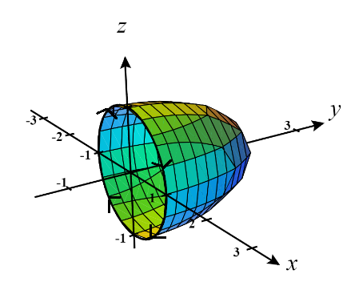
We see that the boundary curve to this surface occurs when which means that we have the curve . To orient the boundary curve C positively we parameterize C by where .

Since the hypotheses of Stokes’ Theorem are satisfied, we have that:

- Suppose and C is the boundary of the part of the plane in the first octant. Given that C is oriented counterclockwise as viewed from above, use Stokes’ Theorem to evaluate
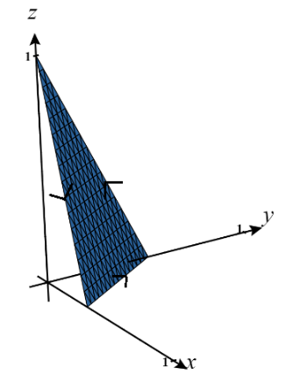
.

We start by sketching a picture of the surface and its projection into the xy-plane which is defined by

We see that and so we define . Therefore, we have that:
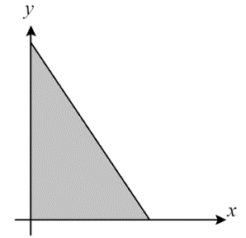
&

Since the hypotheses of Stokes’ Theorem are satisfied, we know that .

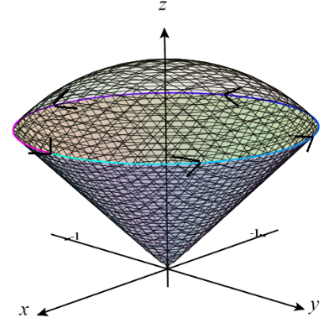
- Let and C be the intersection of the cone and the sphere with a counterclockwise orientation as you look down the positive z-axis. Evaluate .

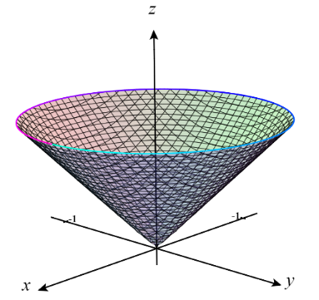
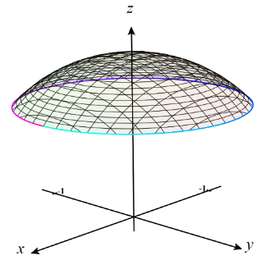
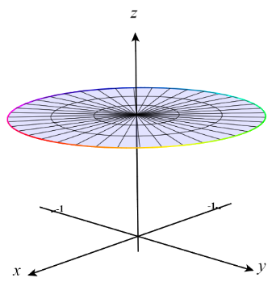
We first sketch a picture of the intersection described. If we intend to use Stokes’ Theorem to calculate the given line integral we must be able to identify . From our picture we actually see that we have multiple choices for a solid for which C is a boundary curve.

We can select any of these surfaces to work with, but we will choose the plane since it appears easiest.

We calculate that . This is an interesting result that should make our integral calculation very easy even without fully describing .
Since the hypotheses of Stokes’ Theorem are met we know that:
- Let and C be the triangle in the plane with vertices , , and with a clockwise orientation as you look down the positive z-axis. Evaluate .

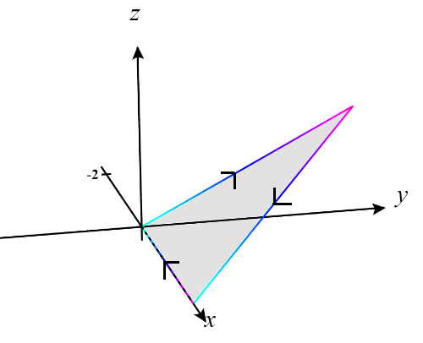
We start by sketching a picture of the surface and its projection into the xy-plane which is defined by

We see that is already in the form and so we define . Therefore, we have that:
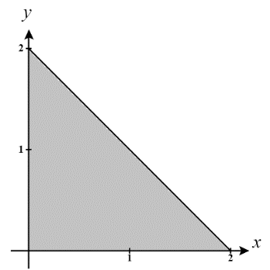
&
In order to have C be positively oriented with respect to we need to have downward facing normals and so we will use

Since the hypotheses of Stokes’ Theorem are satisfied, we know that

- Consider the vector field . Let be the portion of the sphere where .
- Find the flux of through with respect to outward pointing normals.

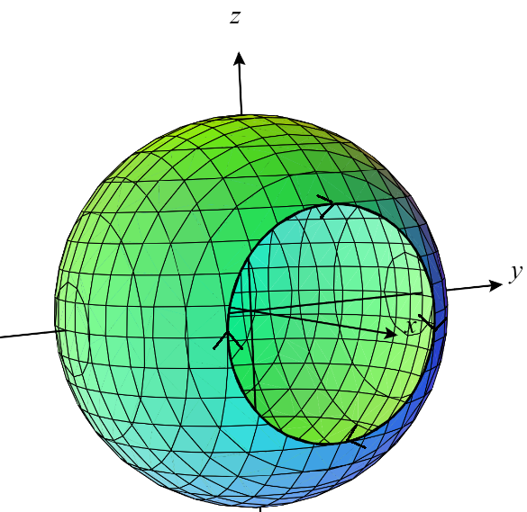
We sketch a picture of the surface and determine that its boundary curve occurs when on the sphere. This means the boundary curve C has the formula:

In order to give C a positive orientation we will parameterize it by for .

Since the hypotheses of Stokes’ Theorem are satisfied, we have that:

- How would your answer from part (a) change if we instead worked with the portion of the sphere where .

As a result of working with this new portion of the sphere we would have almost all details of the problem the same. The only thing that would be different is the orientation on C (sketch a picture if you cannot visualize this). Because of this, our answer will simply be multiplied by -1 and we will obtain a flux of .

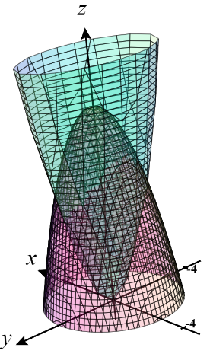
- Let and C be the intersection of the paraboloid and the paraboloidwith counterclockwise orientation as you look down the positive z-axis. Evaluate .

We start by sketching a picture of the two surfaces. The intersection of these surfaces is difficult to picture so we will attempt to determine it algebraically. We know the intersection occurs when the two surfaces are equal and therefore we determine:
This means that the projection of the solid into the xy-plane is an ellipse.

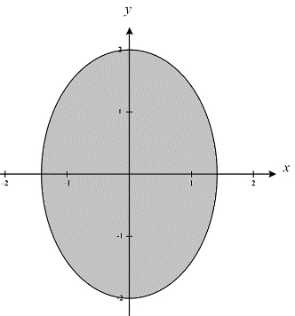
Much like in problem #3 we have a couple of different choices of solids for which C is a boundary curve. Specifically we can use either the top half (determined by) or the bottom half (determine by ) of the “capsule” formed by the intersection of the solid. However, since our curve C is said to have a counterclockwise orientation as we look down the z-axis we must work with since C is the boundary of this curve when oriented counterclockwise.

We see that is already in the form and so we define . Therefore, we have that:
&

Since the hypotheses of Stokes’ Theorem are satisfied, we know that

We previously found D to be an ellipse and so to make integrating over it easier we will use a change of variables to rework the region D into the unit circle.
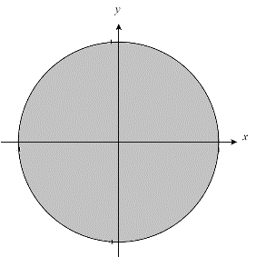
Let then we see that S is determined by
So, and has the following picture

Therefore, our transformation is and the Jacobian of this transformation is
Thus,

- Let be the surface parametrized by for .

- For the vector field , directly evaluate , where n is a unit normal that points in the positive x-direction.

We begin by calculating the and n.
&
We see that points in the negative x-direction and so we will use .
Therefore, we have that,

- Check your answer to part (a) by computing using Stokes’ Theorem.
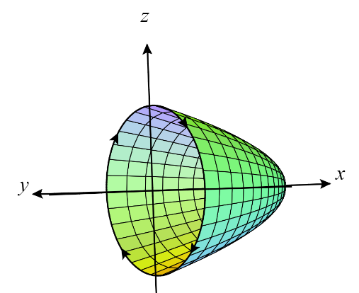
We see that the surface has a boundary curve C when , which is a circle of radius 1. In order ensure that C has a positive orientation we parameterize it as where .

Since the hypotheses of Stokes’ Theorem are satisfied, we have that:

